AWS application deployment

AWS is a famous cloud provider used by majority of the organization

The common approaches to deploy a spring boot inside AWS is either EC2 or Elastic bean stalk

EC2 – Elastic compute cloud

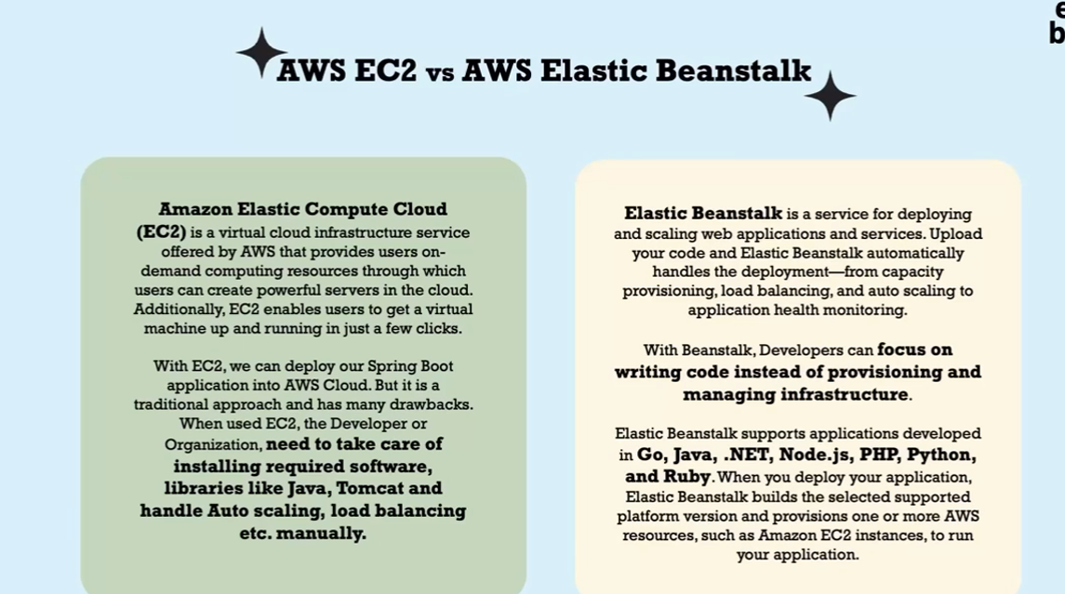

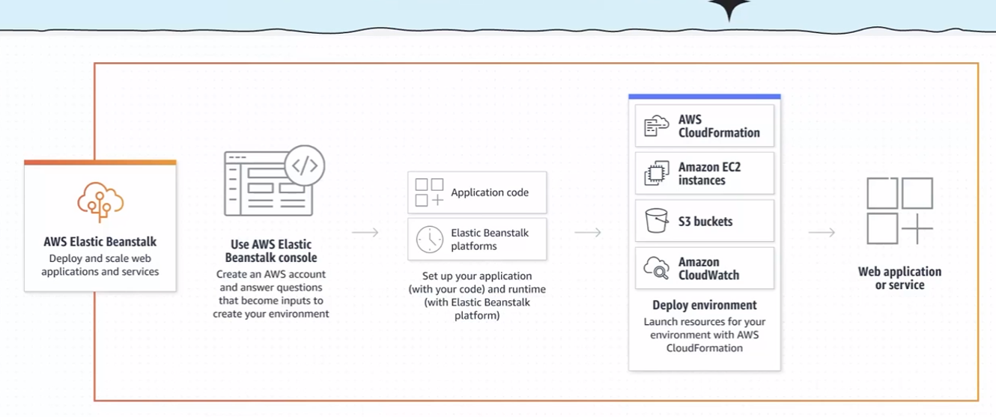

To deploy our application we will make use of Elastic bean stalk as it has advantages over EC2.

Whenever we want deploy an application on ESB it asks for platform that our application is going to run for eg: Java once the necessary information is provided then AWS Esb will automatically take care of creating EC2 instance and the required resource for running of our application this information is provided in the form of script that contains commands. AWS ESB will also automatically takes care of load balancing and scaling of our application.

Whatever jar or war package we have provided will be stored in S3 bucket .

Cloudwatch is going to monitor our application.

Now lets create jar of our application by adding packaging tag to jar in the pom.xml

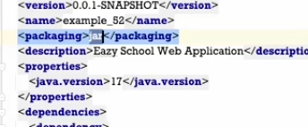

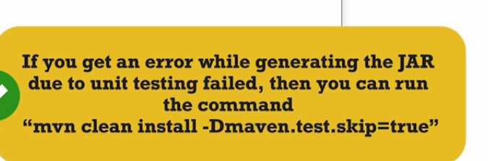

Then we can also set name for the jar in pom.xml

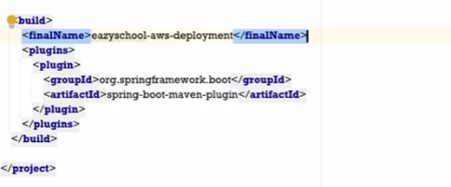

Once the jar is created then its time to deploy our application

Goto aws elastic bean stalk website if we don’t have account then create and login. After login you will see home screen as below

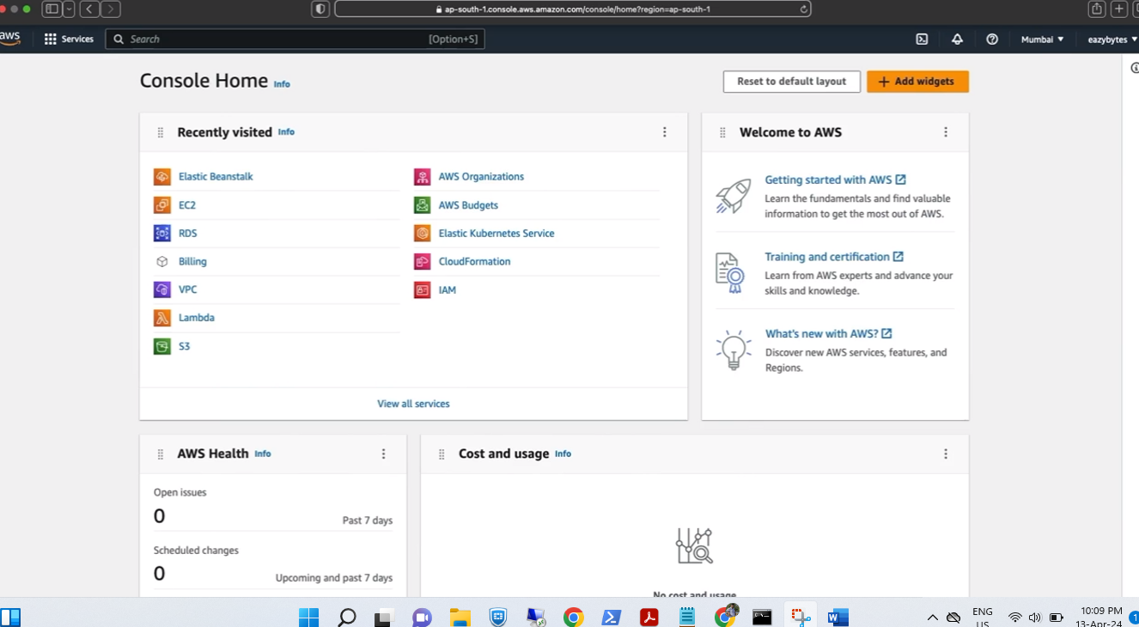

Then in search box search for Elasticbean stalk

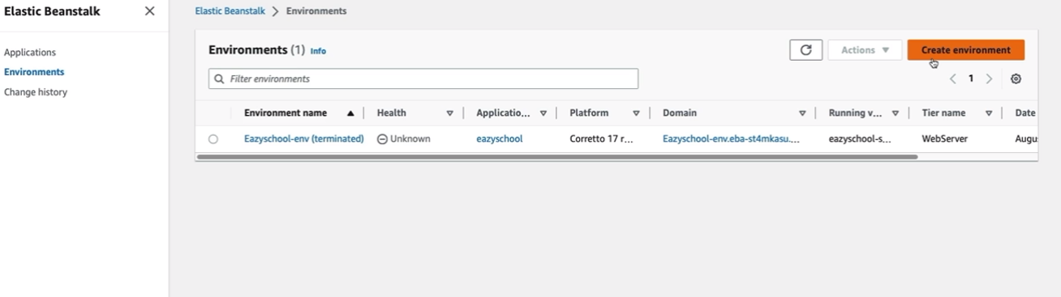

Click on new environment. Provide the environment name then select the platform as below

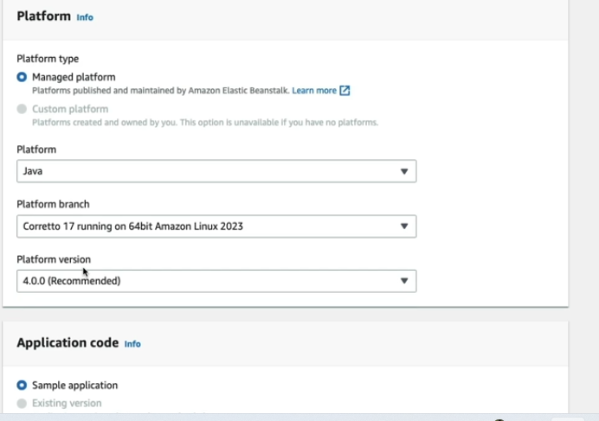

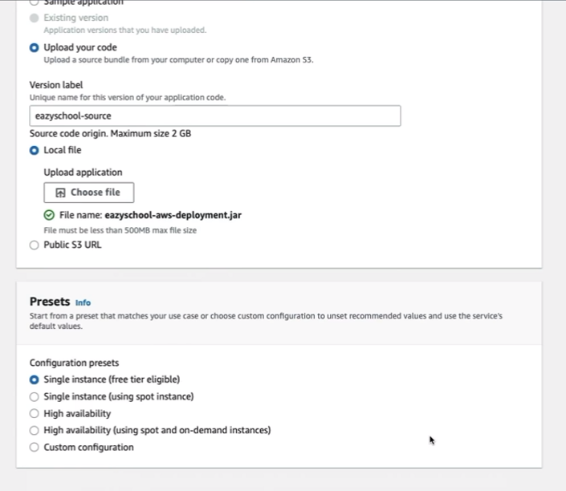

Then select upload your code option then choose file and upload your jar

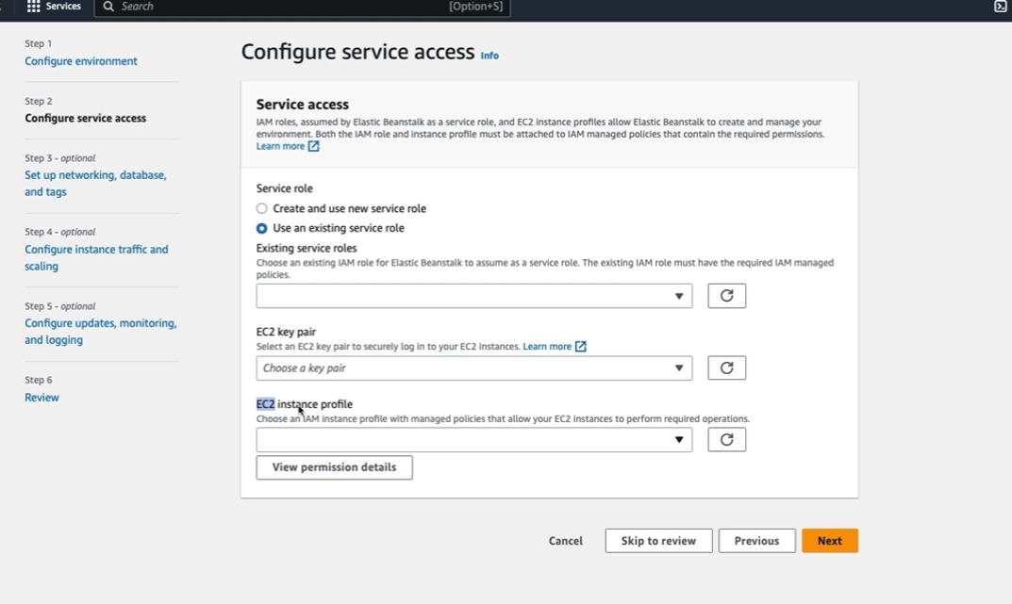

Next step is to provide the privileges to the EC2 instance profile as it is automatically created by ESB for that we need to goto IAM service search IAM service in search bar

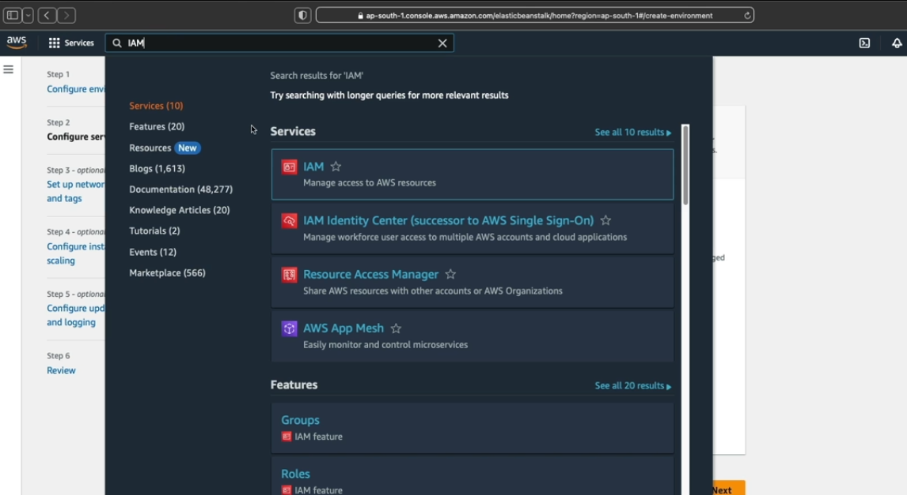

Open IAM in new tab you will see a dashboard that contains list of roles available

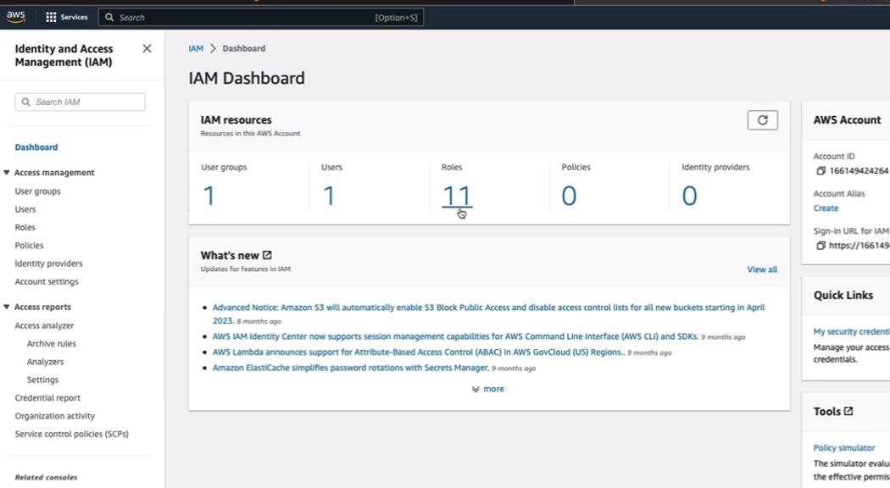

Then select roles there are some predefined roles by ESB. But these are not sufficient we need to create custom role click on create role

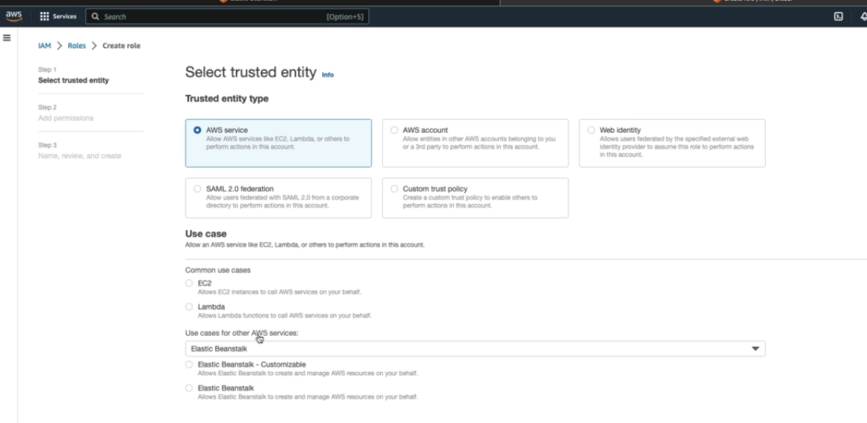

First will be creating AWS service role and search for Elastic beanstalk and select the one with customizable

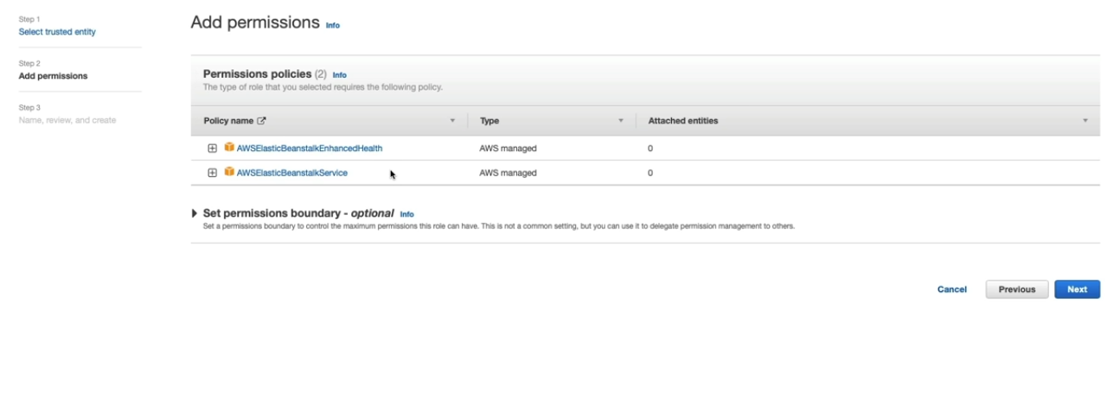

These 2 will be added by default then click on next then on next page give the role name and the create.

Now add another role this time also we need to select AWS and in Use case select EC2 then click on the next On Next page you can see policies we need to select 3 for the Elastic bean stalk instance profiles as per documentation

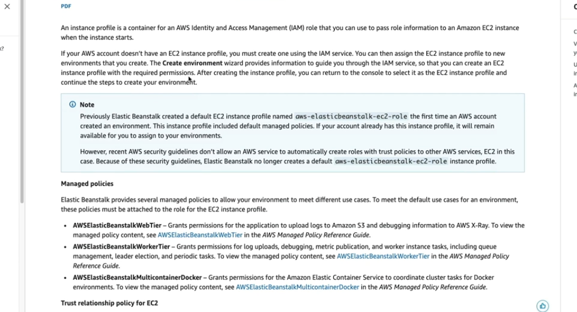

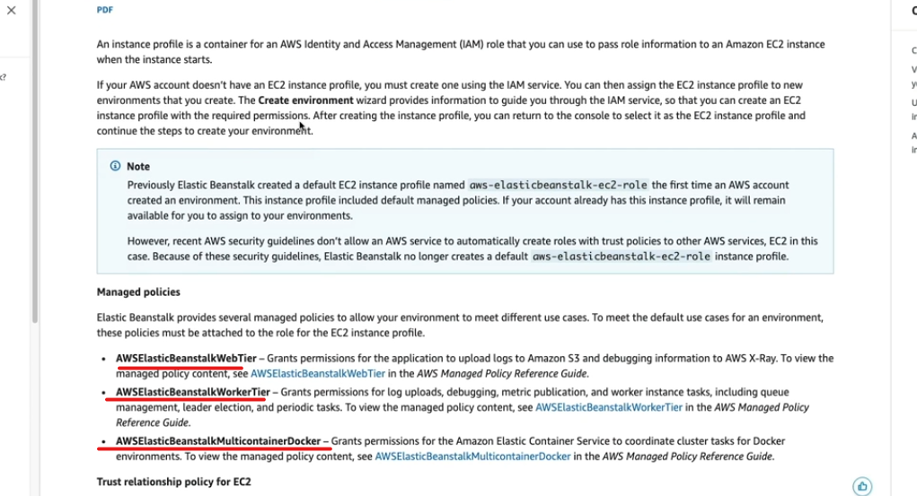

Then hit next add Name and create role

Then coming back from IAM to previous screen choose the roles and services

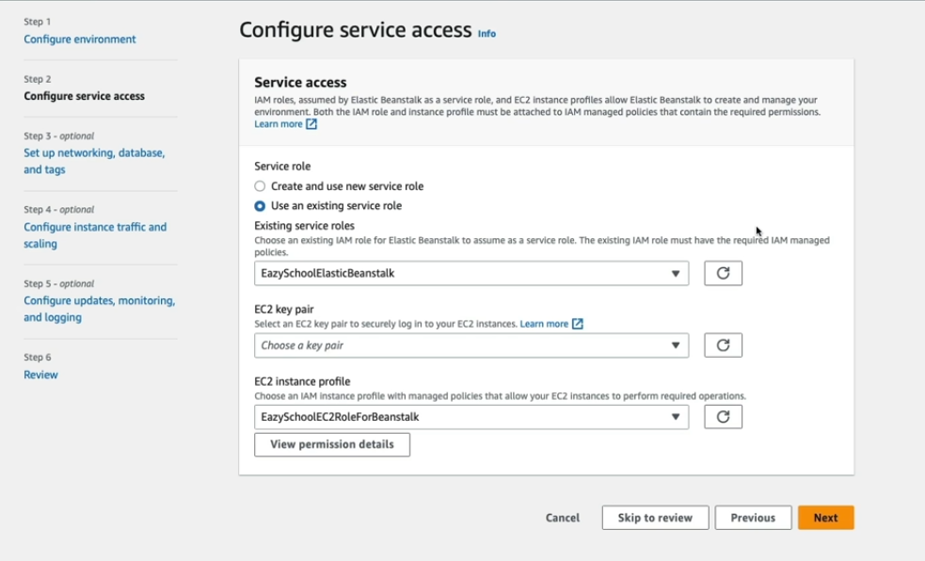

Then select Next you will see setting up network, database and tags. You don’t have make any changes and hit next

Then on next page Configure updates,monitoring and logging also we don’t want to make any changes only we need to make change related to Environment properties

We should not set port at 8080 instead define some other value as ESB will recognize the request coming at port 8080

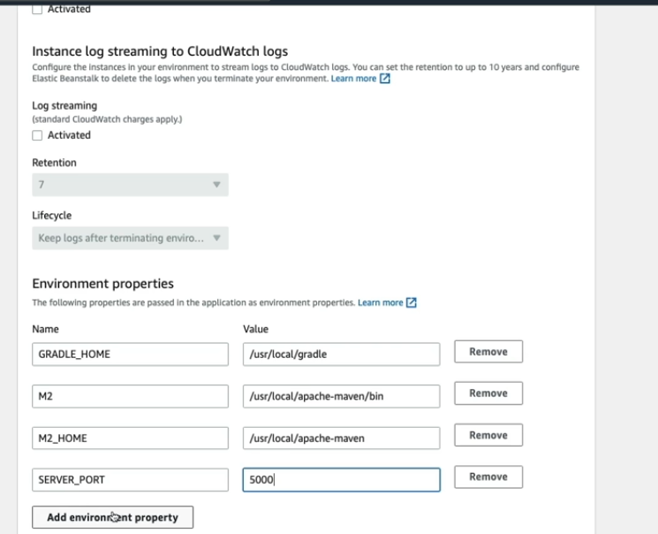

Then click Next and review the page and submit, After some time you will receive the msg successfully created

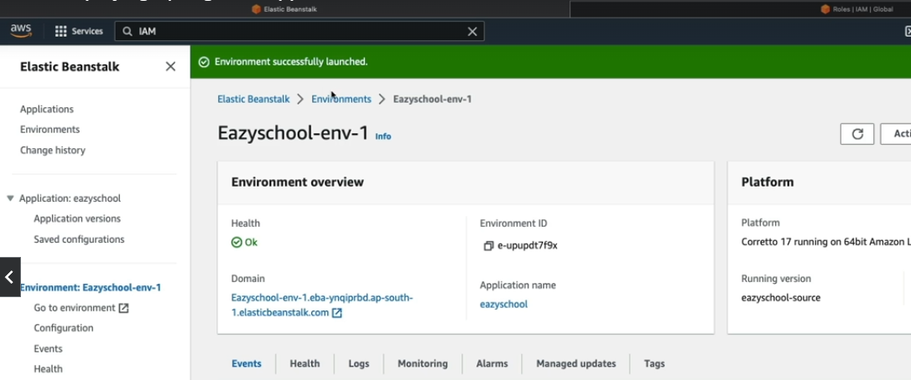

You can also switch between properties as currently its set to UAT

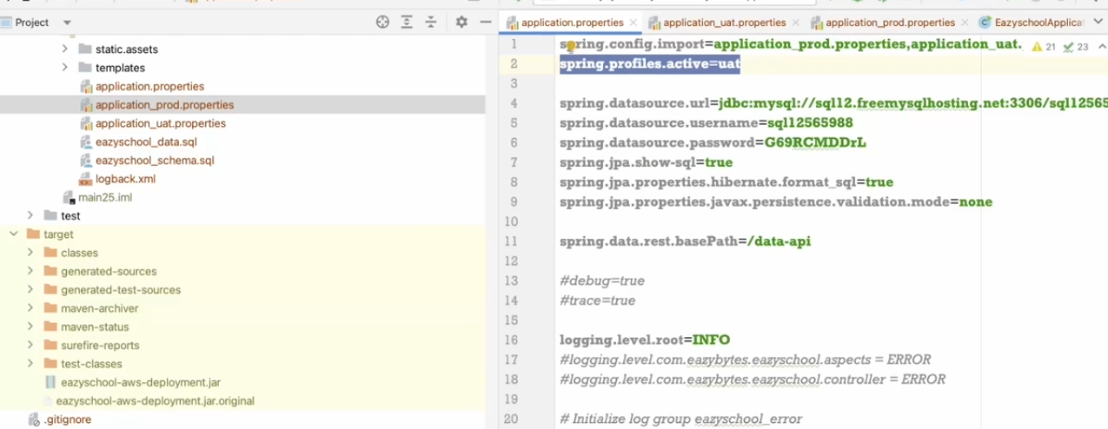

To change to prod add environment properties to AWS ESB instance

For that select your instance and goto configurations available at the left hand side

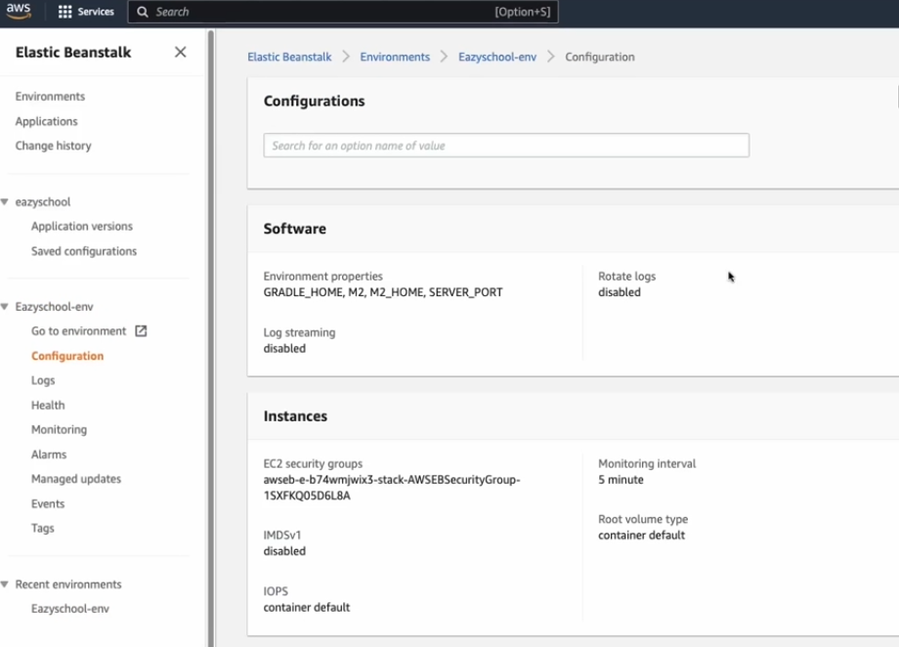

Then Edit the software scroll down and goto section Environment properties

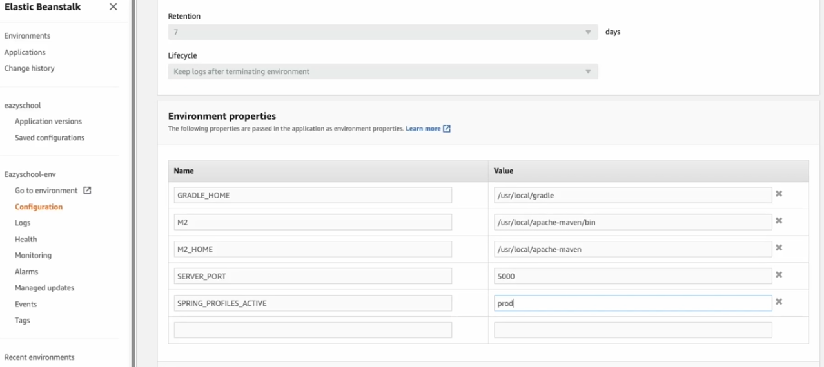

Hit apply the redeploy happens and works as prod